Introduction Model WE-686
Wellcare Naturcare Sound Relaxation
For Stress Relief, A restful night’s sleep

。Feel the nature, immerse yourself in nature to relax and be peaceful
。Wellcare’s Naturcare Sound Relaxation is wonderful for stress relief, meditation, sound masking and a restful night’s sleep. I mimicked 7 natural sounds – heartbeat, sea waves, brook, birdsong, woods, white noise and rain. Immerse yourself in a natural sound environment helps you mask or ignore annoying sounds.
。The sound of heartbeat comforts infants and children, as if they are sleeping in their mothers’ arms.

Why need Naturcare Sound Relaxation
. There are many sounds in the environment, some have no effect on one while some tend to make one easily distracted or unpleasant, and some even make people feel uncomfortable like goosebumps, cause stress, affect mood, study, work and life, also affect sleep quality.

. Sound is a personal subjective experience. Everyone has different acceptance and influence degrees for type, frequency and volume of sound. Most people can adapt to it gradually, but not everyone can do that.

Who suitable for using Naturcare Sound Relaxation
. Using a sound machine is a good idea for those with sensitive hearing, tinnitus and certain unpleasant sounds that cause stress.

. Heartbeat Mode has the effect of soothing and stabilizing emotions, suitable for 1st year newborns and hyperactive children.

How it work
. Wellcare Naturcare Sound Relaxation digitally records the sounds of nature, simulates returning to nature, receiving natural sounds for healing, triggering the associations with natural pleasant experiences.
Although the voice still exists and has not disappeared or changed, it can soothe the original unpleasant sounds on one by distracting one's upset by listening to natural sounds and ignoring the original unpleasant sounds.

. Unlike music or tunes, Wellcare Naturcare Sound Relaxation plays harmonious sounds by repeating 7 sounds from Heartbeat, Sea Waves, Brook, Birds, Woods, White Noise and Rain. With natural background sounds, the frequencies are different and can divert attention, make one ignore or forget unpleasant sounds, help achieve relaxation and peace, reduce stress, and improve sleep quality. One of the modes 'Heartbeat', which is similar to mother's heartbeat, soothes infants and hyperactive, emotional children, helps them stabilize mood and sleep.

Features
In addition to providing 7 kinds of sounds, it can do volume adjustment, control the upper limit of the volume to avoid the long-term effect of hearing loss as the sound becomes louder and louder.

. Spherical shape and spherical stepless volume adjustment knob: By holding with both hands, it gives people a sense of stability and peace of mind.

. Easy to operate, use 4 *AA batteries(not included with product) or AC adapter(optional)

What’s the difference between Wellcare Naturcare Sound Relaxation and others?

. Wellcare Naturcare Sound Relaxation WE-686 has been on the market for more than 25 years and has been used by more than 1,000,000+ people in Europe and America.
. Thanks to experts for adopting Sound Ball (Wellcare Naturcare Sound Relaxation) as a research, more than 5 years of research (2010-2015), (Hyperacusis in children: The Edinburgh experience) The results of the study show Wellcare Naturcare Sound Relaxation as an good intervention in the behavioral treatment of hyperacusis children. The research report June 2018 was published in a well-known journal: International Journal of Pediatric Otorhinolaryngology.

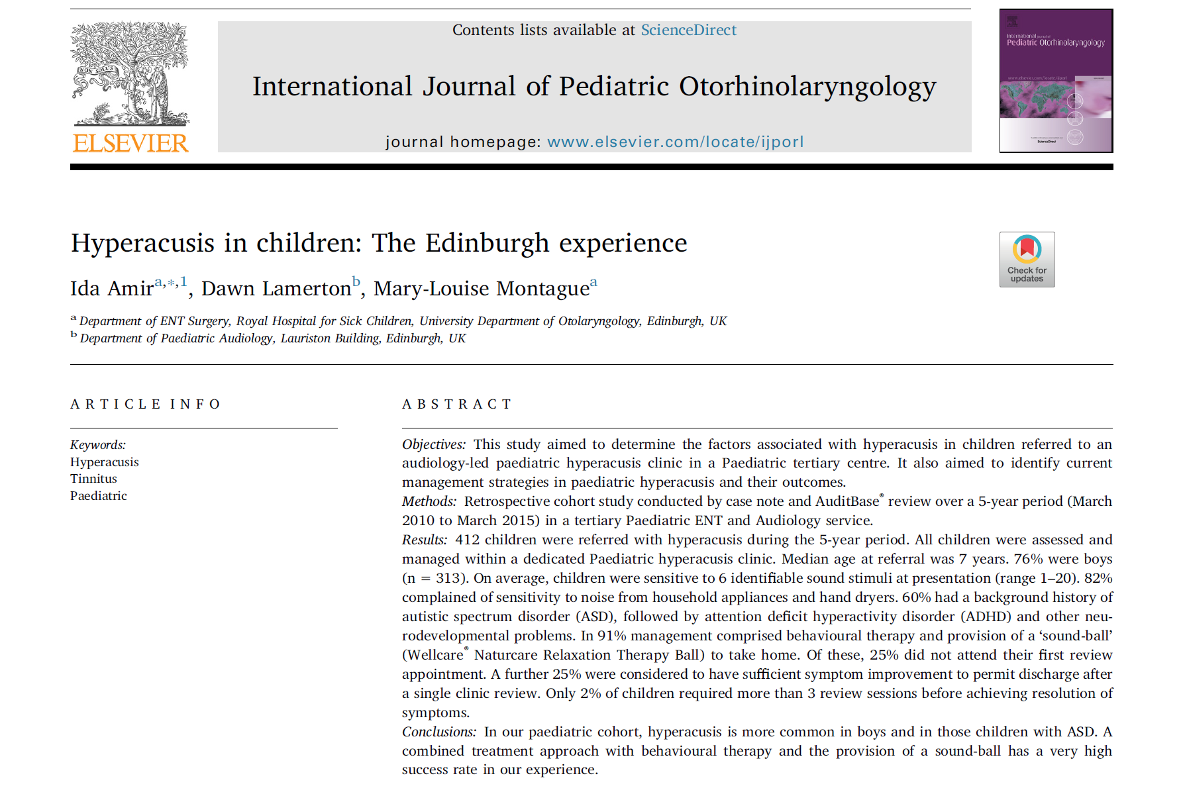

Conclusion
. Some customers leave a message, they are recommended by audiologists or behavior therapists, TRT therapists or otolaryngologists to buy Wellcare Naturcare Sound Relaxation and get positive results. Stress, improving sleep, and improving tinnitus trouble their lives, although the unpleasant sound has not disappeared, but they have learned to ignore it.

. Disclaimer: Due to individual variability, results cannot be guaranteed to the same degree in all cases.

Customers Review (UK)
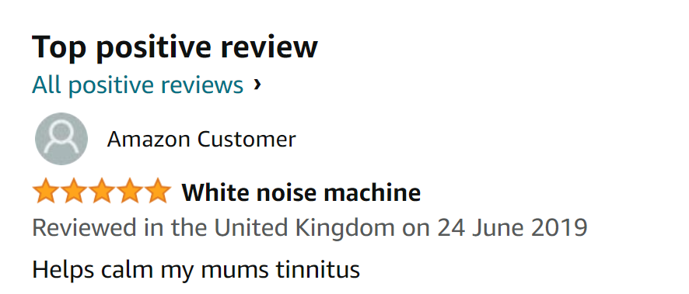
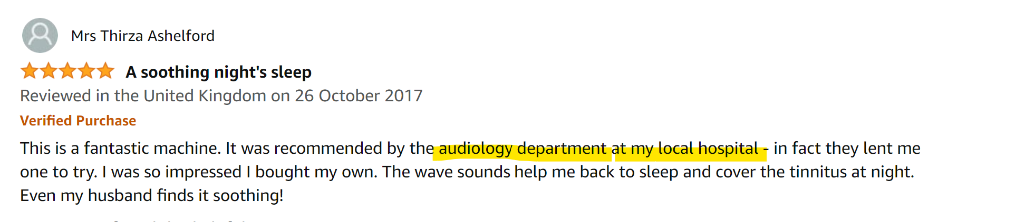
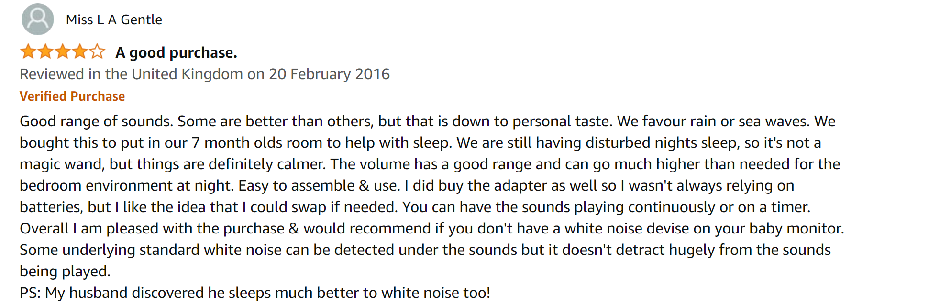

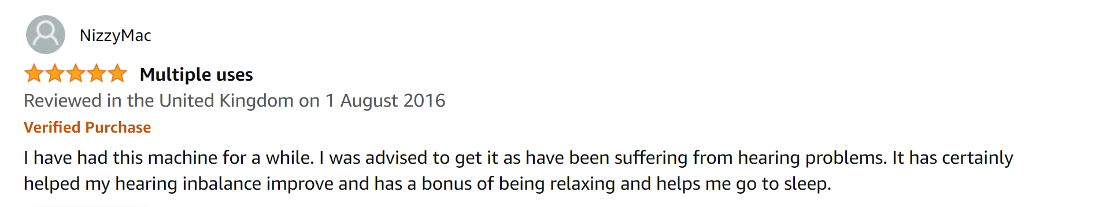
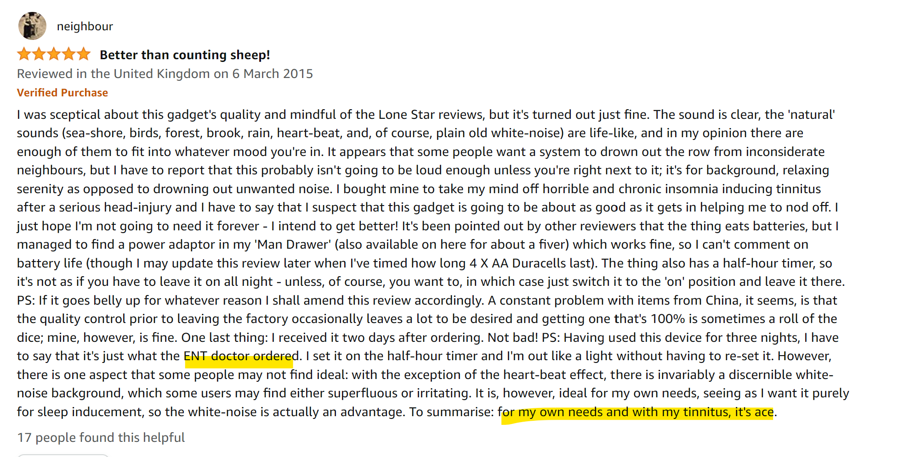

- END -

